MICKS CAFE
PHONE ORDER 47459187
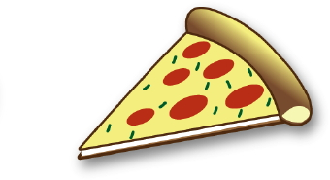
Pizza Menu LARGE $20 SMALL $16
BBQ Meat Lovers
BBQ sauce base Grounded beef, ham, pepperoni, Spanish, onion & cheese
Hawaiian
Tomato base shredded ham, pineapple & cheese
Supreme
Tomato base Ham, pepperoni, Spanish, onion, olives mushroom, roast capsicums, pineapple & cheese
Chicken Supreme
Tomato Base Chicken, Spanish onion, olives, pineapple, mushrooms, roast capsicums & cheese
Pepperoni
Tomato base pepperoni & cheese
Cajun Chicken
Cajun spiced chicken, bacon, mushroom, Spanish onion & cheese with a mint yoghurt swirl
BBQ Chicken
BBQ sauce base Chicken, bacon, mushroom, Spanish onion & Cheese
Vegetarian
Mushroom capsicum sun dried tomato olives onion spinach &cheese
MICKS CAFE
PHONE ORDER 47459187
Gourmet Pizza
LARGE $24 SMALL $18
Garlic Prawn
Marinated in garlic spinach Spanish onion fetta sundried tomato & cheese
Smoked Salmon
Smoked salmon cream cheese Spanish onion capers & cheese

Pizza Deals
- 2 large pizzas and 1.25ltr drink $35
{not including Gourmet}
- 2 large pizzas garlic bread and 1.25ltr drink $ 40 {not including Gourmet}
- 2 gourmet pizzas garlic bread an 1.25ltr drink $50
- 2 gourmet pizza an 1.25ltr $45

